CAS PY 106

Pre-lecture Note 12

1. Resistors in Parallel
2. 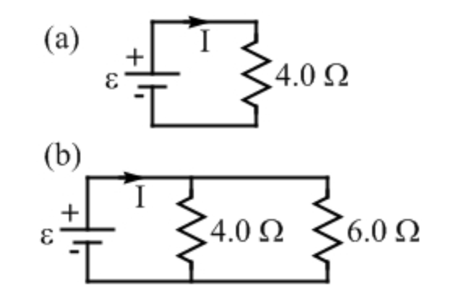
3. When charge has more than one path to choose from between two points in circuit, we say that those paths are in parallel to one another
4. Adding resistor to a circuit can decrease resistance of tat circuit if the resistor is placed in parallel with another resistor in the circuit

1/R = 1/R1 + 1/R2 +…+1/Rn

1. 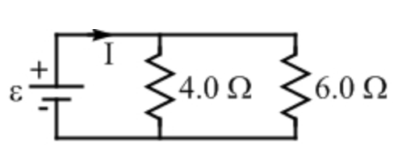
2. Assuming the battery is 12V, the current is higher for resistor with 4 since more of charge passes through the lower resistance path
3. The total resistance is 1/(1/6+1/4) = 2.4
4. Current supplied is therefore I = V/R = 12/2.4 = 5
5. Current through resistor of value 4: I = 12/4 = 3
6. Current through resistor of value 6: I = 12/6 = 2
7. Current added: 3 + 2 = 5, which matches with current supplied initially
8. Splitting the Current
9. 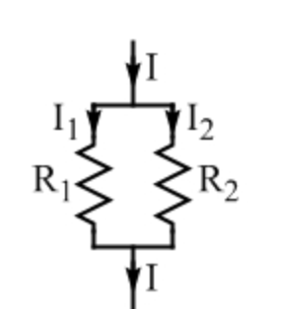
10. The current entering particular section of circuit is I, which is then divided into I1 and I2 which has resistors, R1 and R2, respectively
11. Current through R2 is…

I = I1 + I2 🡪 I1 = I-I2

And

V = I1 \* R1 = I2 \* R2

V = (I-I2) \* R1 = I2 \* R2

V = I \* R1 – I2 \* R1 = I2 \* R2

I \* R1 = I2 \* R1 + I2 \* R2

I \* R1 = I2 (R1 + R2)

I2 = I\*R1 / (R1 + R2)

1. Current through R1 is

I1 = I \* R2/ (R1 + R2)

1. If two resistors with 10 and 30 are in parallel, the fraction of current entering the 10 resistor is:

I1 = I \* R2/ (R1 + R2)

Assuming V = 10,

I = 10/7.5 = 1.33 🡪

I1 = 1.33 \* 30 / (30+10) 🡪 I = 1

AND

I2 = I\*R1 / (R1 + R2)

I2 = 1.33 \* 10 / (40) = 0.3325

I1 with resistor 10 is three times bigger than I2